**Project Overview: Attendance Camera System**

This project involves a camera system designed to track attendance and absences. The camera records students as they enter a facility, recognizes their identity, and logs the data into an Excel spreadsheet. If a student arrives after 8:00 AM, the system automatically marks their entry with a warning indicator in the spreadsheet to denote tardiness and issue a warning. This ensures accurate attendance records and timely alerts for late arrivals.

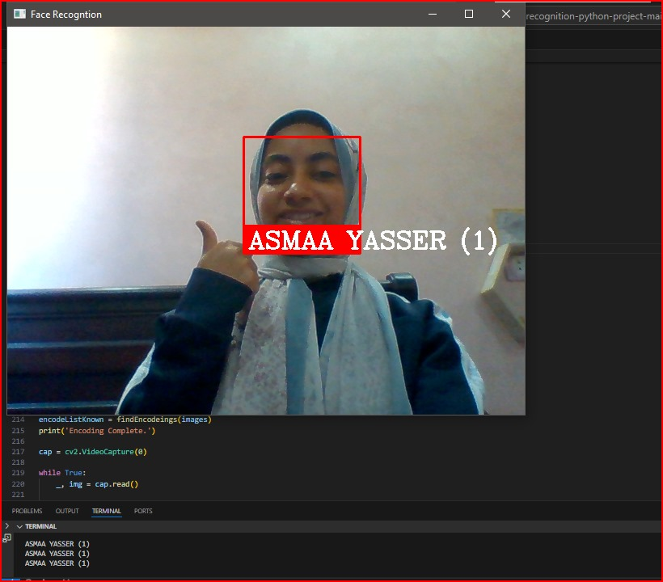

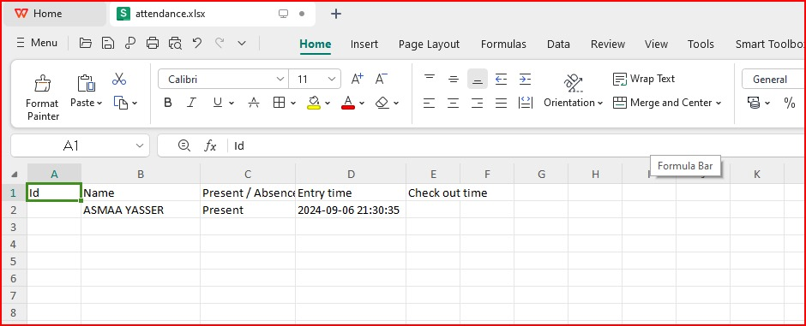In this figure that detect the person with his name

In this figure that document the time of attendance of the student